
Red Balloon Project Request Fall 2013 (REVISED)
Instructor – Kris G Munsch
Institute of Applied Technology
Project: Build a ¼” = 1” scale two bedroom home with a single car garage. This model will have working electrical, scale HVAC, model plumbing, etc. The model will be used in teaching across disciplines within our program and for demonstrations at events held throughout the school year. The model will include working drawings.
Who will be involved? Any student within the Institute of Applied Technology will have the opportunity to get involved in the project. All instructors in the program will also be involved to some degree with metals, woods, electrical and research for the purpose of publishing our results.
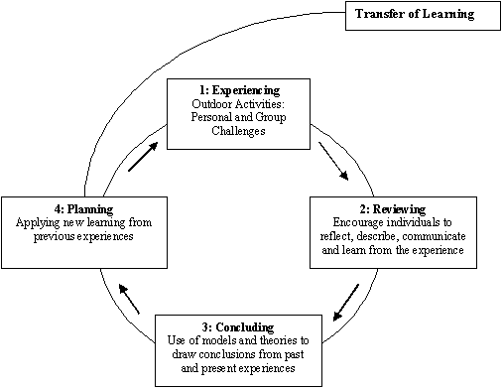
How does it advance the learning experience? Dr. David Kolb has blazed a path in experiential learning over the past several decades creating a model (Kolb, 1984) based on experiencing, reflecting, concluding, planning and then implementing. Though this may only be a model we will be building, the lasting impact and scaled size of it will allow for students who not only build it but anyone who investigates the construction in the future the ability to plan and implement many of its features into any future building project they encounter.
Implementation Strategy: This project will use blended learning and instructional styles, but will mostly fit within the true meaning of our department, “applied technology”. Applying skills in communication/drafting, electrical, wood working, metals, team work, leadership.
Timeline: Students have already done research on floor plans. During the fall semester, the Construction Graphics class will begin the build with plans to complete the entire build of the project by December 2013. The research will continue on during the spring of 2014.
Estimated Cost: $3,000
Assessment: Assessing this project will be done in three ways. One, in finished product and the understanding of going from working drawings to actual scale model by preparing a journal article. Two, in presenting this project to other students, staff and local opportunities. Three, many of the students who will be involved in this build go directly into the Building Construction course the following semester. By evaluating their understanding of what they learned during the model construction and how they apply it in the real world build of a garage will be documented through test and personal survey.

